[](http://www.google.ca/imgres?imgurl=http://www.fantasykids.fr/blog/wp-content/uploads/idee-deco-chambre-garcon-fille.jpg&imgrefurl=http://www.fantasykids.fr/blog/2015/04/idee-deco-chambre-enfant-mixte/&h=625&w=500&tbnid=GeVFplgwvmG7EM:&docid=9DhAQ045rHRXNM&hl=fr&ei=qC7yVY-gNIKn-AG4yoGYDw&tbm=isch&ved=0CF8QMyhcMFw4rAJqFQoTCI-U4MPq7ccCFYITPgodOGUA8w)[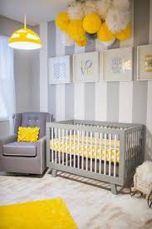](http://www.google.ca/imgres?imgurl=http://media.paperblog.fr/i/699/6994920/idee-chambre-bebe-mixte-L-tuBohG.jpeg&imgrefurl=http://www.paperblog.fr/6994920/idee-de-chambre-bebe-mixte/&h=690&w=460&tbnid=WIS7d4Z6GRd9nM:&docid=kOjiFRT-o8TExM&hl=fr&ei=YjHyVb8Bwef5AY2lnegM&tbm=isch&ved=0CDkQMyg2MDY4rAJqFQoTCL-6lpDt7ccCFcFzPgodjVIHzQ)[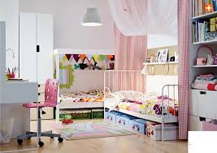](http://www.google.ca/imgres?imgurl=http://picslovin.com/wp-content/uploads/2014/07/ikea-2015-chambre-enfant-coloree.jpg&imgrefurl=http://picslovin.com/collection-ikea-2015/ikea-2015-chambre-enfant-coloree/&h=726&w=1024&tbnid=hwnL4u4jQy_g5M:&docid=7gTGUoMXvZkX2M&hl=fr&ei=My_yVdWlKsLo-AGHzbyYDw&tbm=isch&ved=0CAgQMygFMAU4yAFqFQoTCJWL-oXr7ccCFUI0PgodhyYP8w)[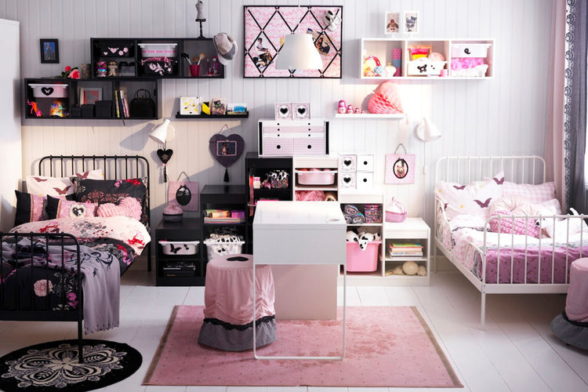](http://www.google.ca/url?sa=i&rct=j&q=&esrc=s&source=images&cd=&cad=rja&uact=8&ved=0CAcQjRxqFQoTCPX0munp7ccCFcsbPgodAocB8w&url=http%3A%2F%2Fwww.linternaute.com%2Fbricolage%2Famenagement-interieur%2Fdeco-chambre-enfant%2Fikea-minnen.shtml&bvm=bv.102022582,d.cWw&psig=AFQjCNHFCplqDKOusi6Vn6skQuLk-iINLg&ust=1442021170240919)